**MVC Application using Entity Framework to Perform CRUD Operations**

**Step 1: Create Project**

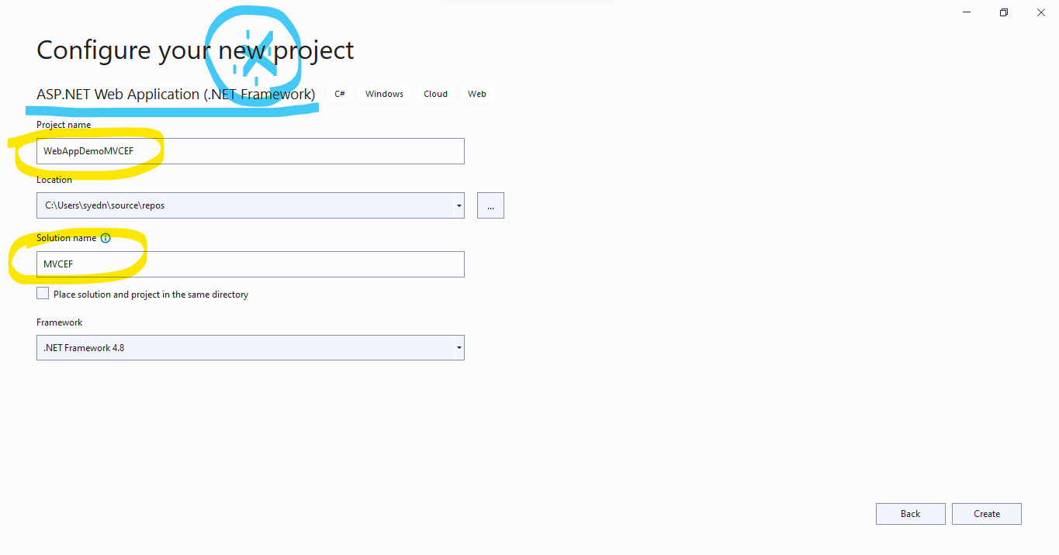

Step 2: Select **MVC** Template

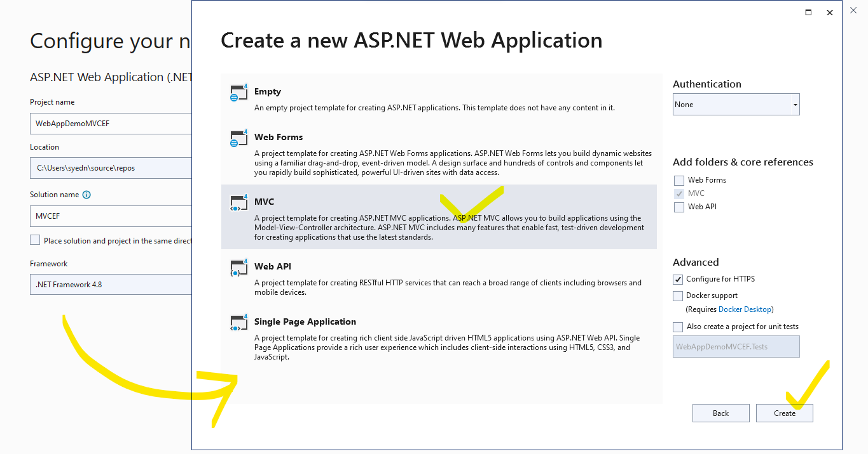

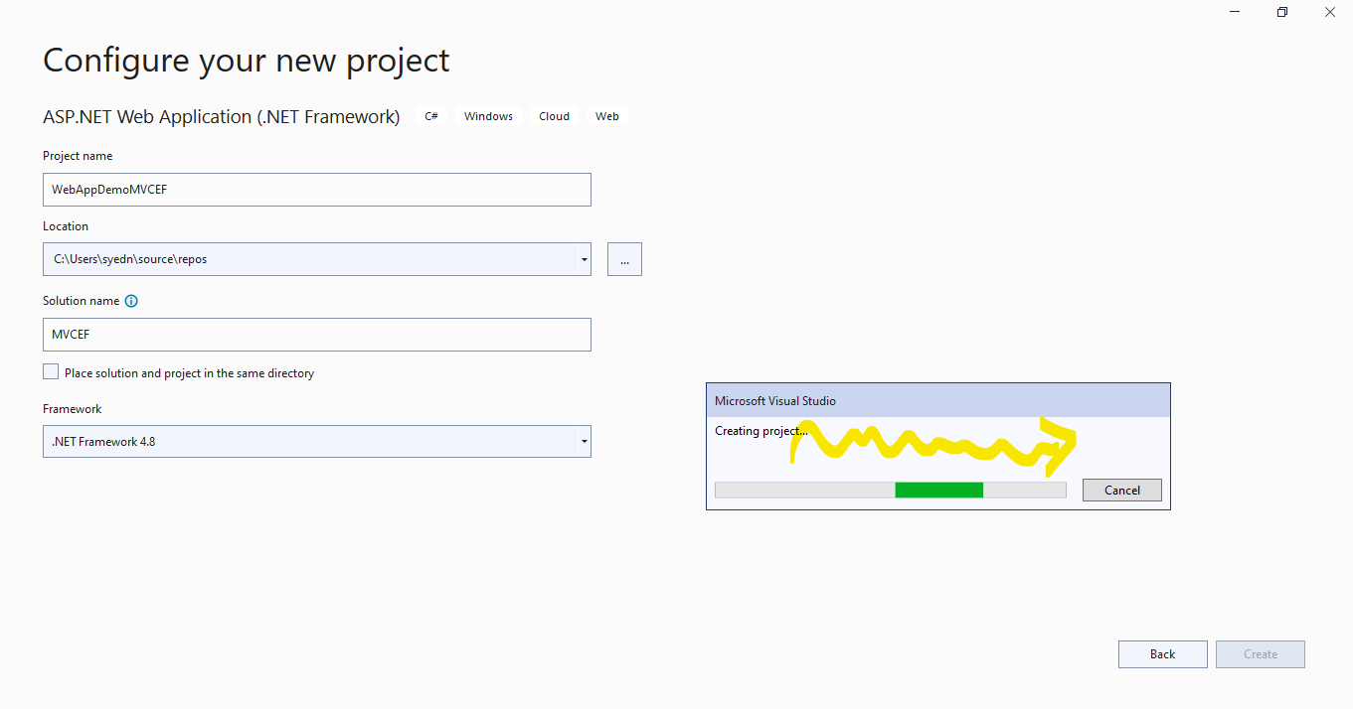

Step 3: Install / Add **Entity Framework** in your project

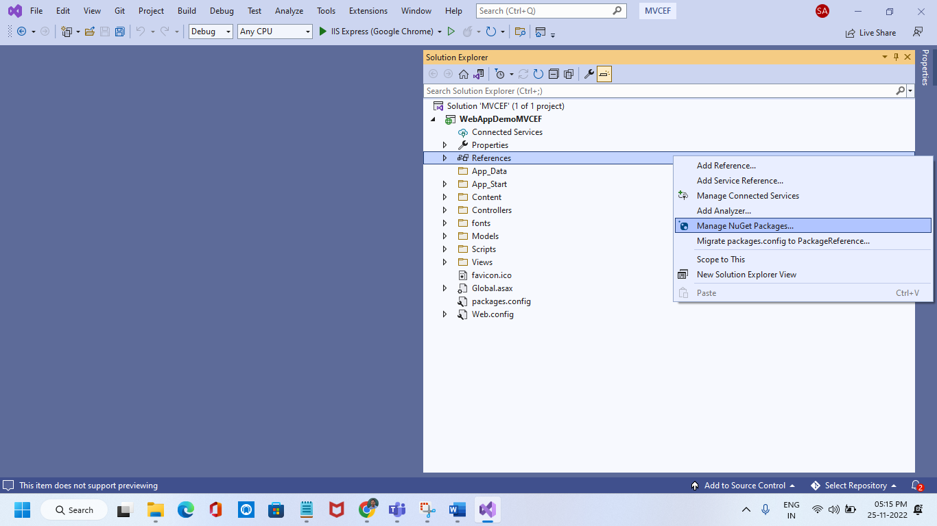

Search **EntityFramwork** in Browse Tab, and Click **Install** Button

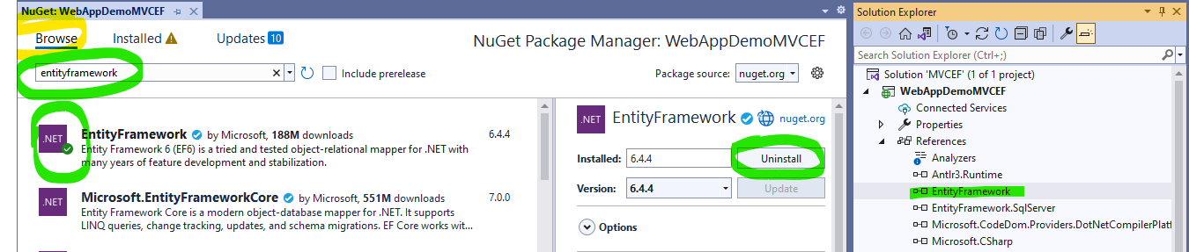

Step 4: Add a **Connection String** for the Database you want to create by **Code-Frist Approach of EF**.

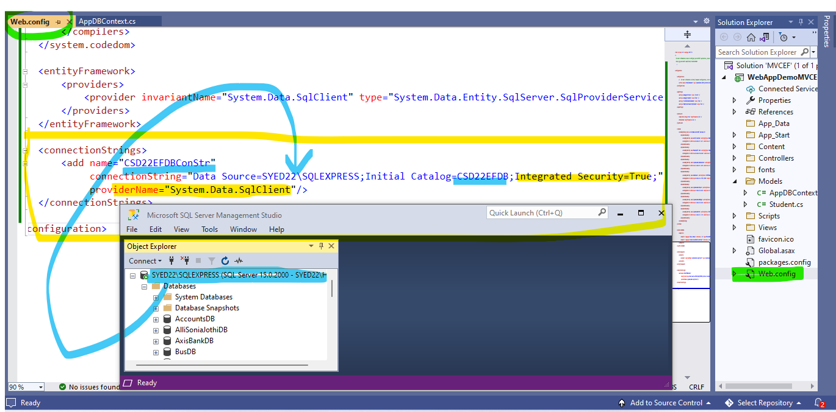

Step 5: Add a Model. Here **Student** is a model.

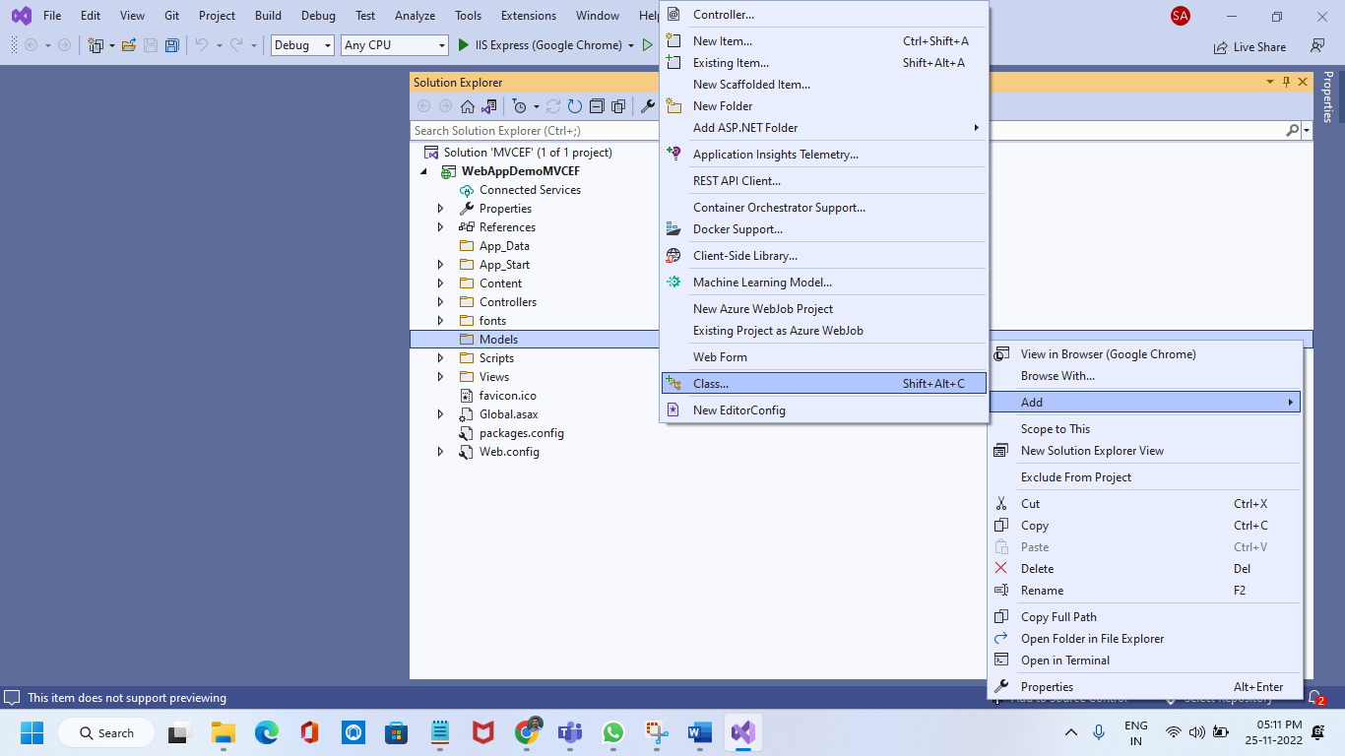

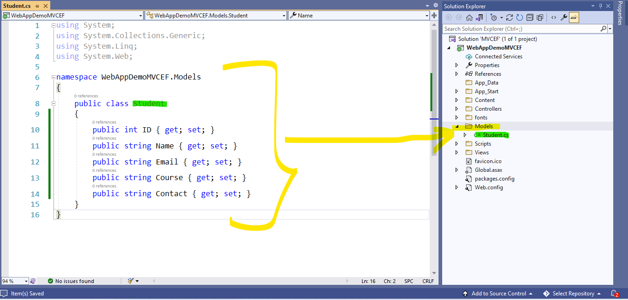

Step 6: Add **AppDBContext** Class for Entity Framework derived from Built-in class DBContext of **EF**

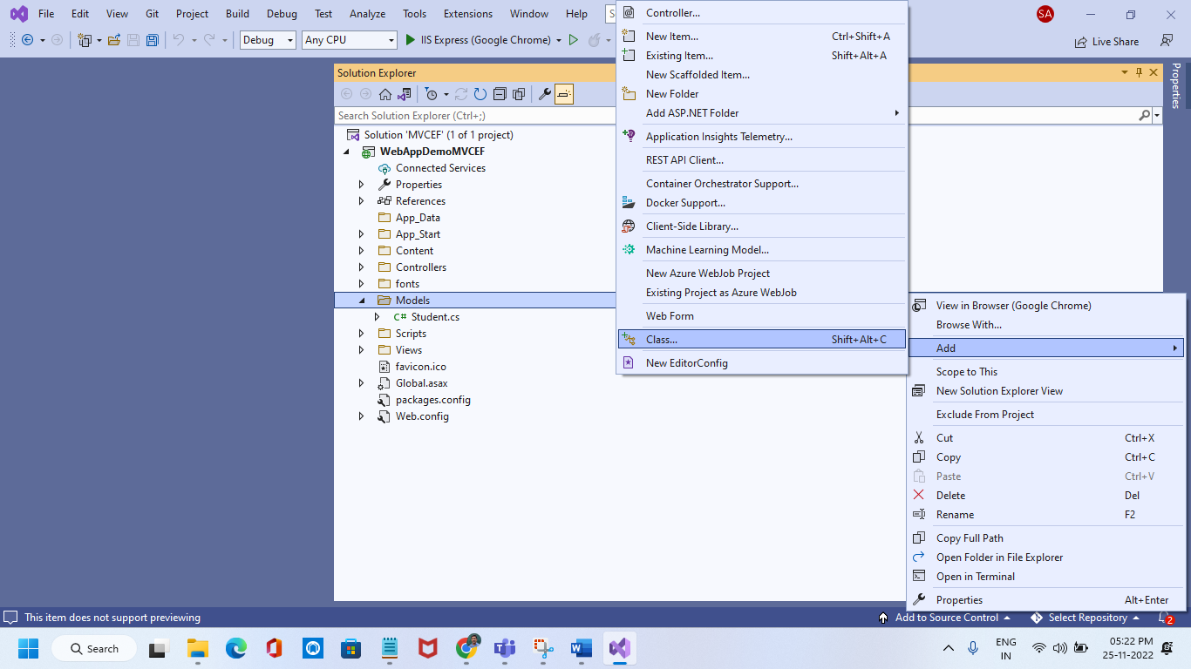

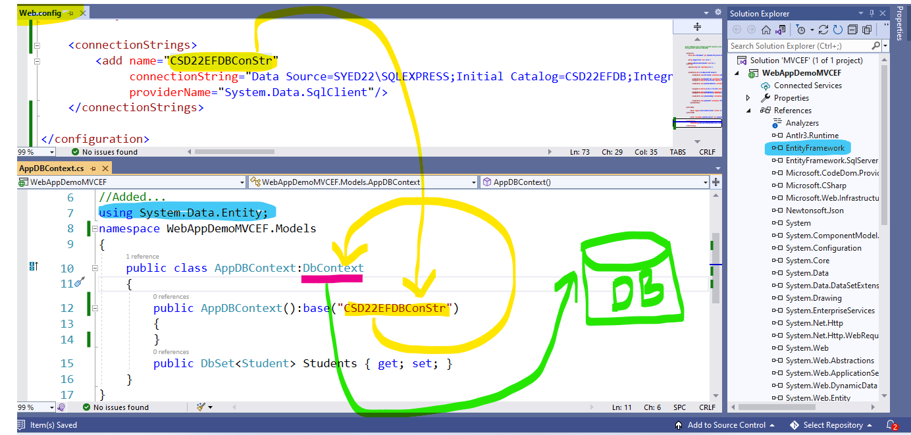

Step 7: Run **enable-migrations** command in Package Manager Console

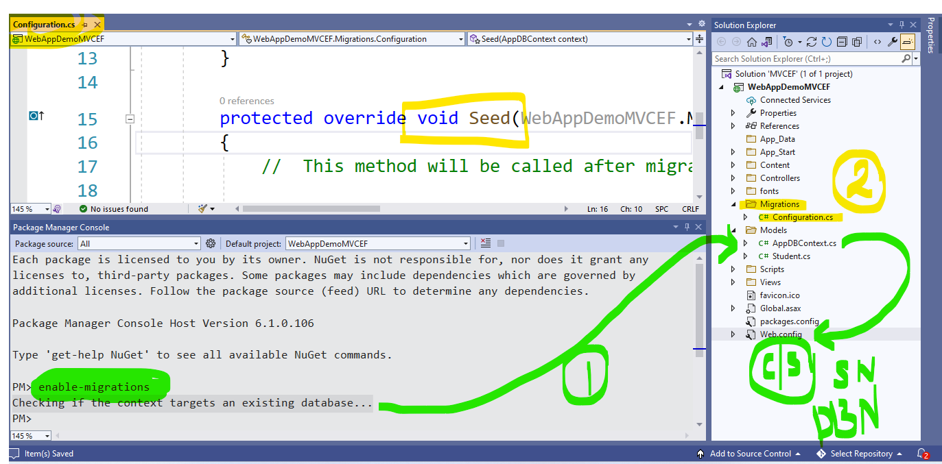

**Step 8: Add the following Code in Seed() method of Configuraion.cs file**

namespace WebAppDemoMVCEF.Migrations

{

using System;

using System.Data.Entity;

using System.Data.Entity.Migrations;

using WebAppDemoMVCEF.Models;

using System.Collections.Generic;

internal sealed class Configuration : DbMigrationsConfiguration<WebAppDemoMVCEF.Models.AppDBContext>

{

public Configuration()

{

AutomaticMigrationsEnabled = false;

}

protected override void Seed(AppDBContext context)

{

List<Student> students = new List<Student>

{

new Student{Name="Vikram",Email="vikram@example.com",Course="Java Technology", Contact="+25-258628"},

new Student{Name="Basil",Email="basil@example.com",Course=".NET Technology", Contact="+25-258694"},

new Student{Name="Kushal",Email="kushal@example.com",Course="Java Technology", Contact="+25-258999"},

new Student{Name="Ankita",Email="ankita@example.com",Course="Linux Administration", Contact="+25-258111"},

new Student{Name="Shravya",Email="Shravya@example.com",Course="Linux Administration", Contact="+25-258111"},

new Student{Name="Shivani",Email="Shivani@example.com",Course="Linux Administration", Contact="+25-258111"},

new Student{Name="Rishita",Email="Rishita@example.com",Course="Linux Administration", Contact="+25-258111"},

};

students.ForEach(s => context.Students.Add(s));

context.SaveChanges();

}

}

}

Step 9: Run add-migration in PMC to create migration class, as below. Migration name is InitialMigration

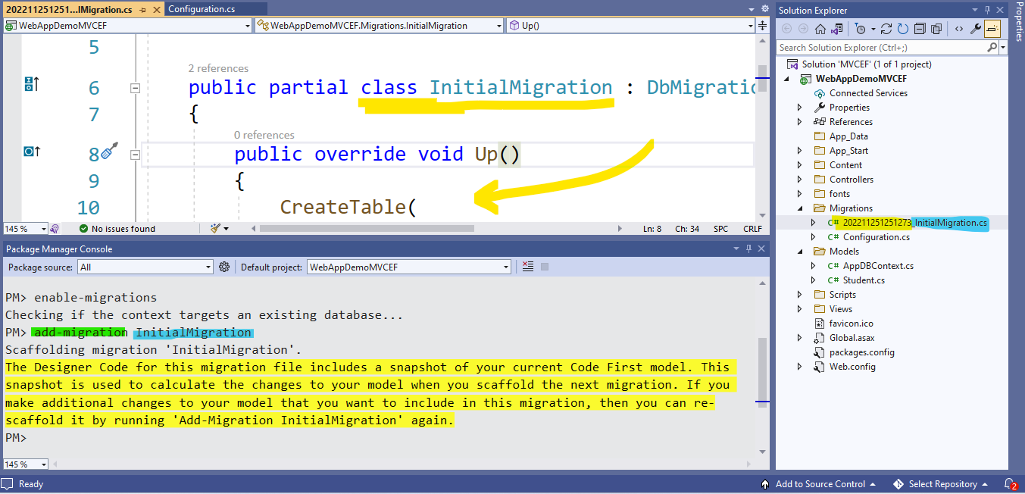

Step 10: Run update-database in PMC, to Create Database and tables and DB Objects

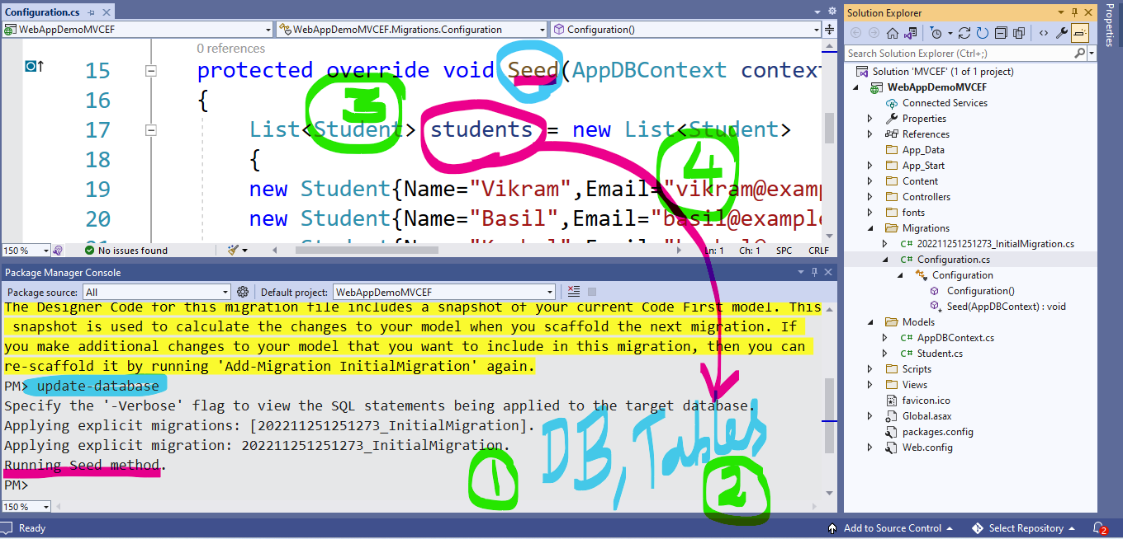

You can check your sql server to see Data Base, Tables crated and Populated

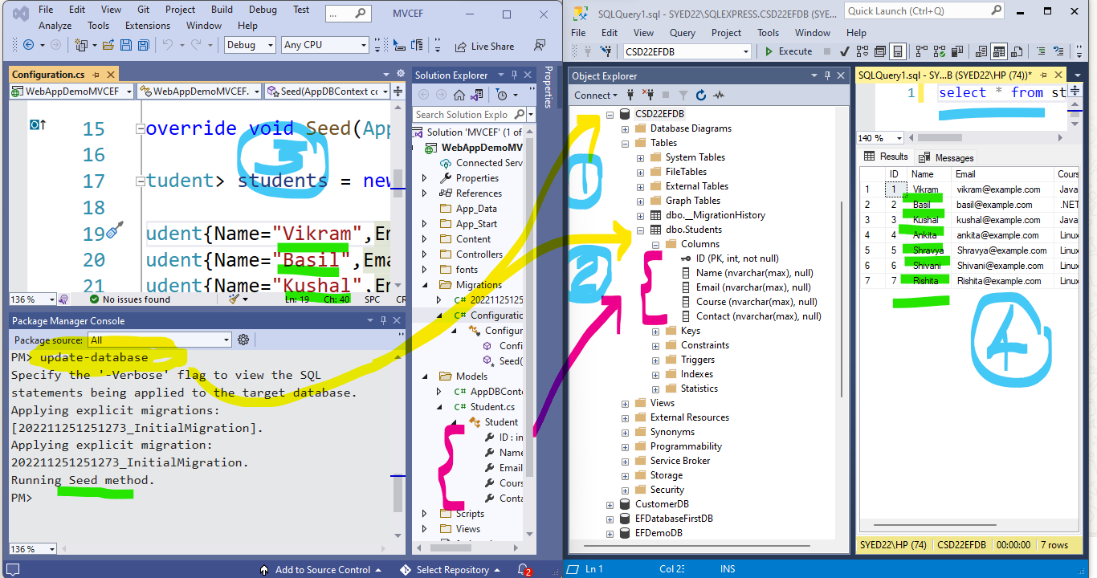

Step 11: Add a Controller with Read, Write Options using Entity Framework as below

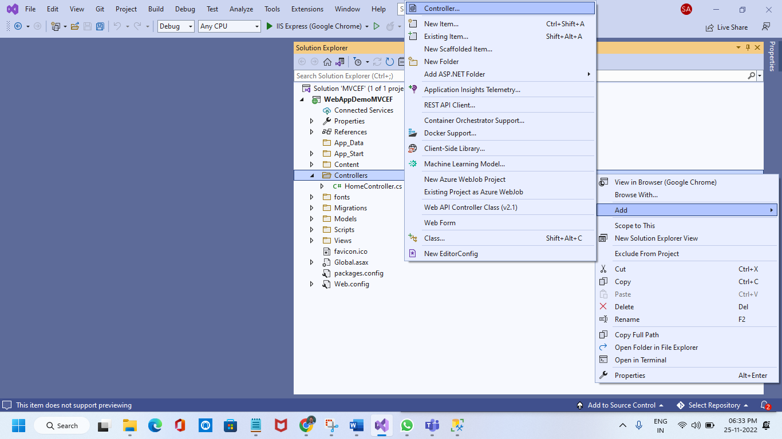

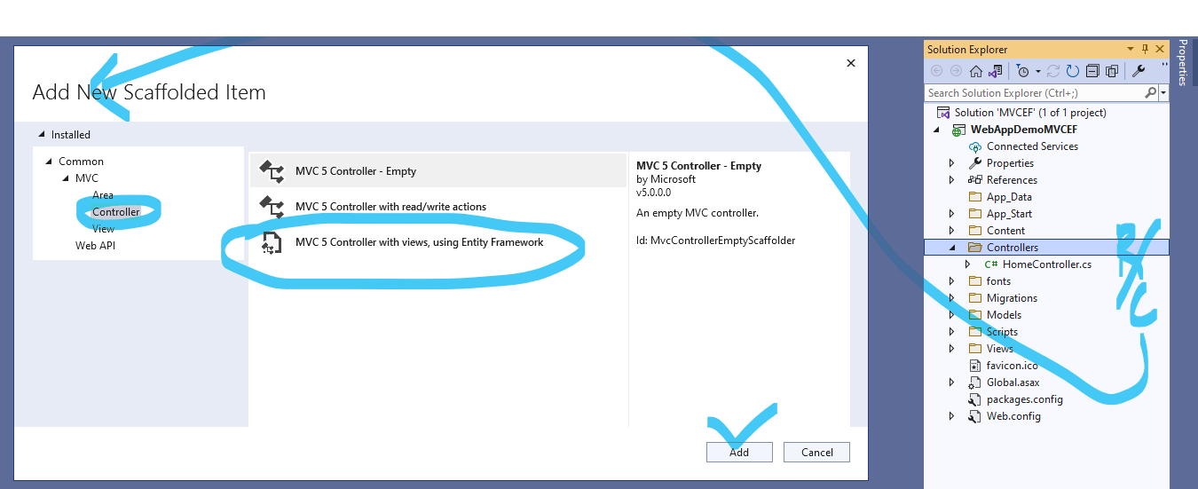

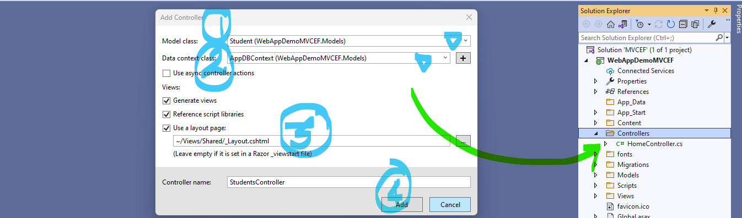

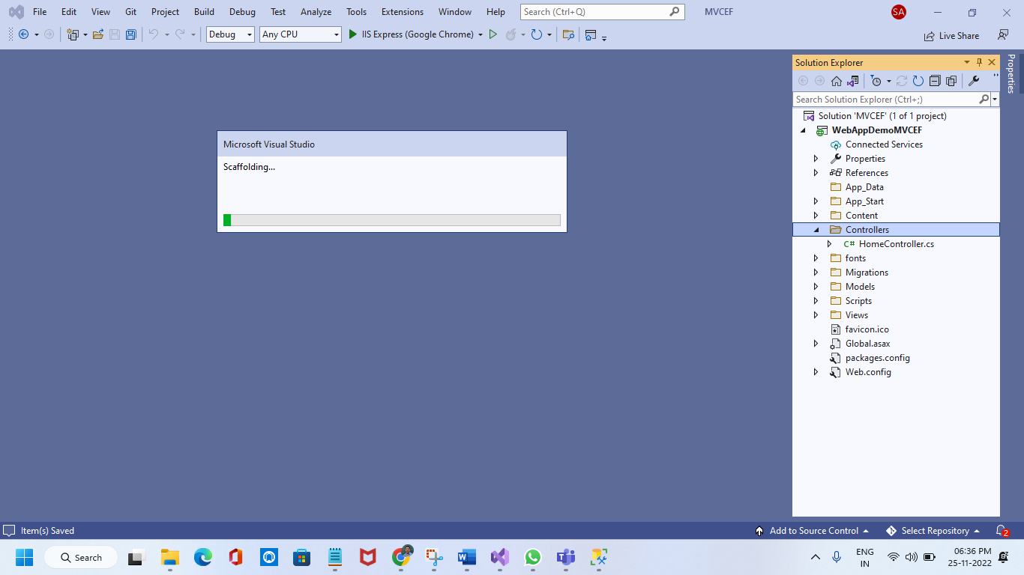

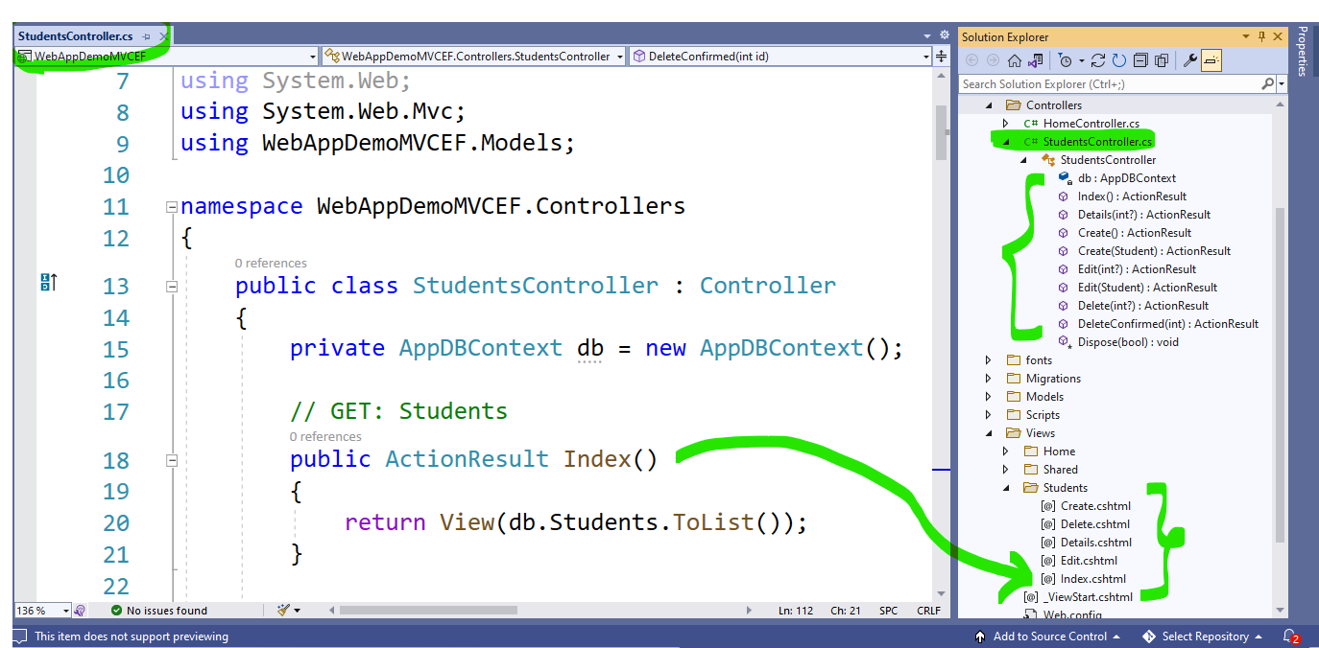

Step 12: Run the application after setting default controller and action method

